System Requirements Specification

Internship Project Name:

Front End – JavaScript Vehicle Selector

Document Instructions:-

- Text written in red fonts is instructions/information for corresponding sections.

- Modify any sections as required and upload the updated document as artifact under specific task in WBS

- Sections 2 to 5 are key and essential for the implementation of the internship projects.

- Section 1, Sections 6 to 8 are for information purpose and any requirements under this section are not required to be implemented as part of the internship project

- Complete the following in Section 4 Use Cases
  - One basic Flow
  - Minimum one Alternate flow
  - One Exception Flow

<Use the table below to maintain information about the document and author. The author is usually the eIntern>

Current Version: | <current version number>
Date Last Updated: | <last update date>
Last Updated By: | <update author name>
Author: | <author name>
Date Created: | <creation date>

Revision History
<The table below can be used to maintain revision history and major changes done on each revision>

Version Number | Date Updated | Revision Author | Summary of Major Changes Made

Table of Contents

1 CarCo Website Project Overview 5
2 Vehicle Selector Page Overview 6
2.1 Vehicle Selector Page: 6
3 System Scope 7
3.1 Users of the Vehicle Selector Page 7
4 User Interface Prototypes (Mock Screens) 8
5 Assumptions and Other Relevant Facts 9
6 Functional Requirements 10
6.1 Behavioral Requirements 10
6.2 Functionality Requirements 10
6.2.1 Processing Requirements 10
6.3 Usability Requirements 10
6.3.1 Ease-of-use Requirements 10
6.3.2 Safety Requirements 10
6.3.3 Documentation Requirements 10
6.4 Data Requirements 10
7 Non-Functional Requirements 11
7.1 Usability Requirements 11

CarCo Website Project Overview

<The internship project “JavaScript Vehicle Selector” is part of the Vehicle Selection Page in a portal for CarCo, a car dealership. The below section explains the page design, functional and non-functional requirements>.

CarCo Site Description:

<Paste CarCo Site Description Here>

Vehicle Selector Page Overview
<This is the description of the internship project. This project should be developed as part of the internship>

Vehicle Selector Page:

The Vehicle Selector Page is a page in the Carco dealership portal where users or dealers can browse the car inventory at the dealership by picking a Car by its body type, Make/Model and Trims.

The users follow the workflow below to view the current car / vehicle inventory at the dealership:
- Body Type: Users pick a body type from a list of links displayed with their graphic icons.
- Make & Model: When a body type is selected in Step 1, the page displays a list of cars available by their Make and Model, along with images if available.
- Trims: When a Make & Model is selected in Step 2, the page displays a list of available trims for the selected car. If more than 1 trim is available, each of them can be displayed sequentially in panels, in an accordion or in tabs. In each available Trim, the vehicle specs are displayed in a tablular fashion.

System Scope

<Give a brief description of scope of work for the project, which defines the boundaries of the work and how it fits in the environment>

Functionalities within the Car Selector Page:
- Body Type Selection: When the page loads, the body type selection section is displayed.
- Vehicle Selection: When user selects a body type, available vehicles having that body type are displayed.
- Trim Display: When user selects a vehicle, the available trims of that vehicle are displayed. If more than one trim is available, they are displayed sequentially.

Users of the Vehicle Selector Page
<Detail all of the roles of people who will interact directly with the system.>

End users of the vehicle selector page are users who are looking for a car at a car dealership.

User Interface Prototypes (Mock Screens)

<These are mock screens for the internship project. This layout and controls can be used in actual implementation of the internship project>

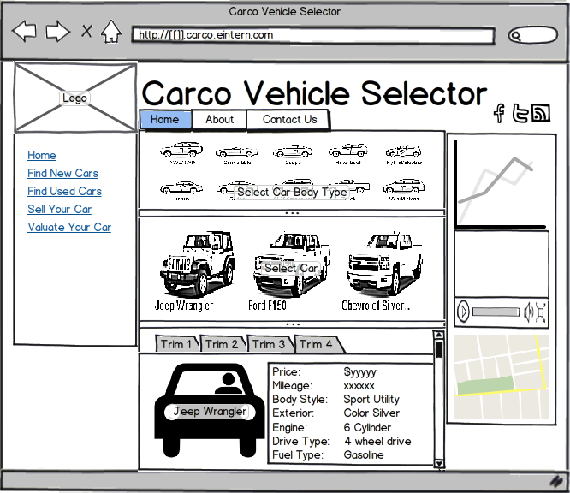

Assumptions and Other Relevant Facts
<This section is for reference and knowledge only. Any requirements under this section are not required to be implemented as part of the internship project>

The system assumes certain parameters and basis which the behavior is defined.

- It assumes that the application will be hosted on the internet as it has to connect to external systems.

Functional Requirements
<This section is for reference and knowledge only. Any requirements under this section are not required to be implemented as part of the internship project>

Behavioral Requirements

- The system must operate smoothly and quickly.
- There should be no page reloads or redirects during the process.
- The page should display and function similarly in all major browsers.

Functionality Requirements

Processing Requirements

  - The system shall be simple and easy to use.
  - The page shall use cross browser compatible techniques for presenting the content in an intuitive fashion.

Usability Requirements

- The system shall be intuitive
- The system shall clearly display all the details and the necessary UI’s should be provided.
- The system shall require minimum amount of input to enhance performance.

Ease-of-use Requirements
The system will have a high level interface for users to interact with the functions pertaining to vehicle selection process.

Safety Requirements
The page shall not expose any system vulnerabilities.

Documentation Requirements
Documentation shall be included online for system use instructions.

Data Requirements
All data required in the page will be loaded initially into the page markup. The page will then hide and show parts of the page as per user interactions.

Non-Functional Requirements
<This section is for reference and knowledge only. Any requirements under this section are not required to be implemented as part of the internship project>

Usability Requirements

- Section 508 Compliance and Accessibility: Due consideration shall be given to accessibility features of the website for people with disabilities.

